Sunday, April 30th, 2017
6:00 p.m. – 8:00 p.m. Early bird registration

Monday, May 1st, 2017
8:00 a.m. – 5:00 p.m. Registration

9:00 a.m. – 4:00 p.m. General Sessions, Information Kiosks and Vendors -Ballroom

This year’s conference will kick off all events in the Main Ballroom. We are proud to bring you one of the most diverse agenda’s that we have ever produced. Our planning team believes that emergency preparedness requires all forms of government and all disciplines to work collaboratively before, during and after any large scale event. Hence, our conference will have a resounding theme as the events will all be built around “Stronger Together.” Participants will interact directly with our Tribal, Federal, State and Local partners. Please join us in the Ballroom for all General Sessions. Don’t forget to visit the many kiosks that will provide you the opportunity to find grants, resources, and Information that will assist you with developing, enhancing and further building your program’s capacity and capabilities. Ballroom Map and Kiosk locations can be found in your registration packet.

9:00a.m. – 9:15 a.m. Opening Ceremonies
- Welcome – (Suquamish Indian Tribe)
- Presentation of Colors
- Opening Prayer – Drum and Song

9:15 a.m. – 9:30 a.m. “Welcome to the 14th Annual Regional Joint Tribal Public Health and Emergency Management Conference” –Del Ostenberg, (Spokane Tribe) Chairman of the Northwest and National Tribal Emergency Management Council

9:30 a.m. – 10:15 a.m. KEYNOTE SPEAKER – Gregory A. Smith, MPA, Tribal Liaison Officer/Public Health Advisor, Program Services Branch (PSB) Division of State and Local Readiness (DSLR) Office of Public Health Preparedness and Emergency Response (OPHPR) Center for Disease Control and Prevention (CDC)

10:15 a.m. – 10:30 a.m. Morning Break (coffee, morning snacks)

10:30 a.m. – 11:00 a.m. “Current Legislative Affairs impacting Indian Country today” - Richard Flores, Director of Legislative Affairs and Tribal Relations, National Tribal Emergency Management Council and previous Special Advisor for National Tribal Affairs, FEMA Headquarters, Washington, D.C.

11:00 a.m. – 11:30 a.m. “Administration for Children and Families” - Catherine Adams-Bomar, Regional Administrator, ACFS and Suzanne Everson, Tribal Liaison, ACFS

11:30 a.m. - 12:00 p.m. “Human Trafficking” – Jerri Moomaw, Nationally recognized keynote speaker, trainer and anti-violence expert. Recently awarded by Department of Justice for her work to improve the lives of trafficking survivors. Project Manager, Washington Engage
LUNCH

1:00 p.m. – 2:00 p.m. Visit Information Kiosks, Vendors and Outdoor Displays

2:00 p.m. – 2:20 p.m. “Washington State National Guard and the 10th Homeland Response Force” - CSM Steven L. Saunders, Command Sergeant Major, 1st Battalion 161 Infantry 81st Infantry Brigade (Spokane) 10th Homeland Response Force (Seattle) 10th HRF Engagement, Planning and Training Community Outreach, Washington Homeland Security Regions II, III, IV and SGM Travis E. Wise, WAARNG, (HRF) Homeland Response Force, Outreach Liaison

2:20 p.m. – 2:40 p.m. “Tribal Liaisons and the Washington State EMD” – Alysha Kaplan, Mitigation, Response and Recovery Unit Manager, Emergency Management Division, and Casey Broom, Human Services Program Supervisor and Tribal Liaison, Washington State Emergency Management Division

2:40 p.m. – 3:00 p.m. “Victim Support Services” – Michaela L. Weber, PhD, HS-BCP, Executive Director, Victim Support Services

3:00 p.m. – 3:20 p.m. “Emergency Preparedness Toolkit” – Lou Schmitz, American Indian Health Commission
3:20 p.m. – 3:40 p.m. “Collaborative Emergency Management Planning and Resources” – Robin Beatty, Office of Emergency Communications, United States Department of Homeland Security

3:40 p.m. – 4:00 p.m. “Why the National Joint Powers Alliance” – Jim Kane, National Business Development Administrator

4:00 p.m. - 5:00 p.m. Visit Information Kiosks, Vendors and Outdoor Displays

7:00 p.m. – 9:00 p.m.
Dinner, Networking Social and Silent Auction for ALL Conference Attendees
(All proceeds from the Silent Auction go towards supporting this conference.)

Tuesday, May 2nd, 2017

8:00 a.m. – 5:00 p.m. Registration

Morning Sessions

9:00a.m. – 9:30 a.m. “Pursuing ongoing Education in Emergency Management” – Linda Crerar, Center of Excellence, HSEM and Jim Sande, CEM, National Tribal Emergency Management Education Sub-Committee Chair

9:30 a.m. – 10:00 a.m. “Tribal Pilot Guidance of Declaration” – Richard Flores, Director of Legislative Affairs and Tribal Relations, National Tribal Emergency Management Council

10:00 a.m. – 10:30 a.m. “Indian Country Intelligence Network” – Nathan Nixon, President of the National Tribal Amateur Radio Association and Training Coordinator for the Inter-Tribal Council of Arizona

10:30 a.m. – 10:45 a.m. Morning Break (coffee, morning snacks)

10:45a.m. – 11:00 a.m. “US Department of Energy” – Tom Clawson, Transportation of Hazard Materials across Tribal Lands

11:00 a.m. – 11:30 a.m. “FEMA HMA External Stakeholder Working Group and PDM in Indian Country” – Tracy M. Depew, EMT-1, Director of Emergency Management, Cow Creek Band of Umpqua Tribe of Indians

11:30 a.m. - 12:00 p.m. “Hazard Mitigation Planning” - Tim Cook, Washington State EMD

LUNCH

Tuesday, May 2nd, 2017 BREAKOUTS
 | Main Event | Breakout 1
2:00 p.m. – 3:00 p.m. | “HAMWAN” – Ham Radio Operations by Bart (AE7SJ) | “Good Government To Government Relations” – Tim Collins, Senior Director, Office of Indian Policy, Department of Social and Health Services and Sue Bush, Director, Emergency Management Services, Washington State Department of Social and Health Services
3:00 p.m. – 4:00 p.m. | “ The Tribal Consultation Process at Washington State Department of Health” – Sheryl Lowe, WA State DOH Tribal Liaison | “ESF 2 (Communications) support for ESF 6 and 8 (Mass Care and Healthcare)” – Steve Aberle, NWTEMC Ham Radio Tribal Liaison
4:00 p.m. – 6:00 p.m. | “First Net Presentation, Listening Session and FirstNet Surveys” – Carl Rebstock, National Tribal Government Liaison, Adam Geisler, Regional Tribal Government Liaison, FirstNet and Margaret Muhr, Regional Tribal Government Liaison, FirstNet | “Mapping and Protecting Sensitive Cultural Sites” – Alan Finkelstein, Instructor, LSU  Bring your laptop for this breakout, as Alan will help to download important FREE software to your computer to help you with this important task in your emergency management program.

Wednesday, May 3rd, 2017 BREAKOUT
 | Main Event | Breakout 1
9:00 a.m. – 10:00 a.m. | Alyssa Landen, MPH  Project Coordinator  University of Pittsburgh  Graduate School of Public Health  Center for Public Health Practice | “Human Trafficking and Vulnerable Populations” - Jeri Moomaw, Nationally recognized keynote speaker, trainer and anti-violence expert. She was recently awarded by Department of Justice for her work to improve the lives of trafficking survivors.
10:00 a.m. – 11:00 a.m. |  | “Children and Youth Task Forces” – Suzanne Everson, Regional Emergency Management Specialist, Region 10 Administration for Children and Families, US Department of Health and Human Services
11:00 a.m. – 12:00 p.m. | “CDC Programs and Accessing Technical Assistance” – Gregory Smith, MPA, Tribal Liaison Officer/Public Health Advisor, Program Services Branch (PSB) Division of State and Local Readiness (DSLR) Office of Public Health Preparedness and Emergency Response (OPHPR) Center for Disease Control and Prevention (CDC) | “Hazardous Materials Planning Program” – Susan Forsythe, WA Hazardous Materials Planning Program Supervisor, WA State SERC Coordinator, Washington State Military Department, Emergency Management Division

There will be an emergency communications drill (called Exercise Sweeper 2017) conducted on Vancouver Island from 8:30am to 3:30pm on Wednesday, May 3rd. The conference's amateur radio station will be participating in this exercise. Please stop by our Amateur Radio Station outside to support our Ham Radio Operators and be a part of this spectacular event.

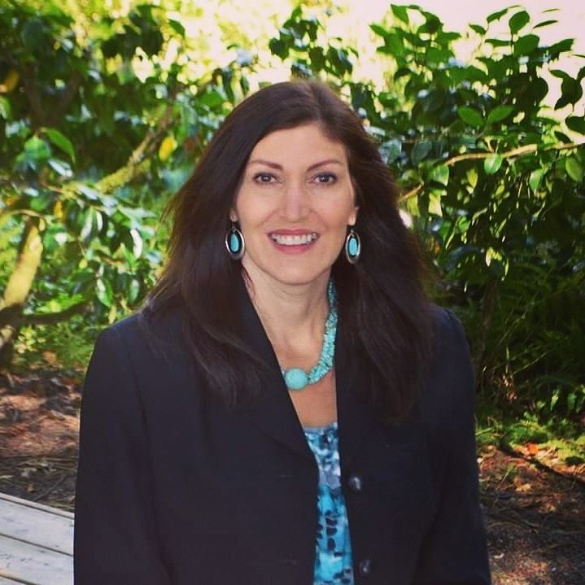
Jeri Moomaw
Jeri Moomaw is a nationally recognized keynote speaker, trainer and anti-violence expert. She was recently awarded by Department of Justice for her work to improve the lives of trafficking survivors. She is a trainer for Department of Homeland Security Blue Campaign and a member of Office of Victim of Crime expert consultant network. She has dedicated her life and work to combating commercial sexual exploitation, human trafficking, gangs and violence against women. Jeri is intimately aware of the specific challenges and issues facing Native communities as well as those facing urban and rural communities more generally. As someone who has been personally impacted by this kind of violence, she also knows first-hand the individual and collective toll it can take. Thus, she has made it her mission to bring awareness, education and tools to equip communities and front line professionals so they are able to recognize and combat trafficking and violence.
A powerful trainer and keynote speaker, Jeri not only shares her own compelling story of exploitation from a survivor’s perspective. She focuses on gaps, system failures and missed opportunities to identify, how to enhance screening and response protocols and how to respond in a culturally appropriate manner. To ensure that attendees receive a comprehensive training program, she positions her personal narrative in the context of hard facts and surprising statistics. Because she focuses on community and individual empowerment, you can expect to walk away from her sessions motivated, educated and inspired. You will know not only what to look for and how to respond, but you will understand precisely how violence against women effects everyone.
In 2016 Jeri trained over 5,300 front line professionals. These include CHI Franciscan Hospital network, Tribal leaders from 11Tribal Nations, Washington State juvenile probation managers, Law Enforcement, San Mateo County gang task force, Thurston County juvenile courts, as well as School staff and students through-out our state.
In 2014, after relocating to Washington State, Jeri joined the team at Washington Engage, an anti-trafficking organization based in Olympia. She currently serves as Program Manager, with duties including policy advocacy, training facilitation, project development and Survivors Voices program management.
In 2016, she started her own non-profit Innovations HTC in Olympia. The mission is to create community wellness through advocacy, education, training and creating economic opportunities for women and survivors of trafficking.
Jeri’s recent career has included working as a consultant for the US Army, Office of Victims of Crime, Administration of Native Americans, Department of Homeland Security, Washington State Senate, federal courts, law enforcement, corrections, and Tribal Nations, as well as other federal, state, city and county government agencies
She holds an A.A. degree in Social work as well as certifications in advocacy, CAASE, motivational interviewing, Healing Arts and Deceptions. She is a recognized subject matter expert on gangs, human trafficking and violence against women, and is often called upon to be an expert witness in trials. Most recently, Jeri has been appointed to the Washington State and Thurston County human trafficking task forces.
Jeri currently lives in Olympia Washington with her husband Alan and enjoys kayaking. She is also an accomplished Native beadwork artist.

Biography for Robin Beatty
Ms. Beatty has 22 years of federal service, also having served in the U.S. Air Force before joining the Department of Homeland Security in 2010. As the Tribal Liaison in the Office of Emergency Communications (OEC), she specializes in tribal emergency communications. She helps federally recognized tribes coordinate with federal, state, and local governments to prepare, plan, and respond to emergency events and incidents. Her work emphasizes preparing for and mitigating risk through shared emergency management operational experience and best practices. She supports OEC in building an understanding of current tribal emergency communications operations, resources, and interoperable emergency challenges; in identifying opportunities to assess, enhance, and support improved tribal emergency communications interoperability through technical assistance; and in assisting Tribes with developing/refining a formal communications governance structure. She is a graduate of Southern Illinois University-Carbondale with a degree in Human Resources and Management Information Systems.

